A7 – LED
Preparation:
We have an LED strip, with a plastic cover and double-sided tape to stick the LED onto the station.
Installation:
We solder a red wire onto the LED strip for the positive polarity and a black wire for the ground. We then slide the LED strip into the plastic cover and finally we place the LED strip onto the double-sided tape and stick it onto the front of the station.
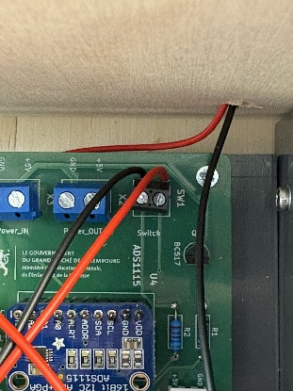
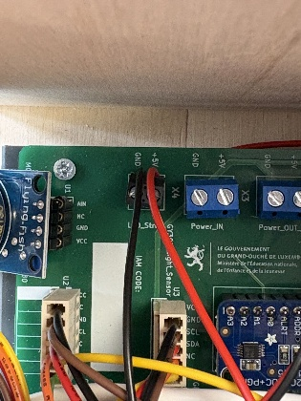
Finally we slide both cables inside the station to connect the wires into a PCB connection terminal marked LED_strip. Then solder a red and black cable on the button we installed on the side of the station and we connect the wires into a PCB connection terminal marked switch.

